The Super Fun and Exciting
To Kill a Mockingbird Comic Strip Assignment

At this point we have completed written assignments for a number of chapters in the novel To Kill a Mockingbird. This assignment will provide an opportunity to work with the book in a different way from the writing we have been doing. Your job is as follows:

- Review the plot of Tom Robinson’s trial in the novel and select what you feel are the key events that most represent the action and meaning.

- Create a comic strip showing the people, actions, and locations involved in the events you have chosen. Your comic strip must contain the following elements:

  - 8 panels.
  - Speech, which is shown using a Word Balloon.
  - Thoughts, which are shown using Thought Bubbles.
  - Explanation of action, which is shown in a Narrator Box.
THOUGHT
BUBBLE!!
WORD
BALLOON!!

- Your comic strip must be fully coloured, contain a title and be full of awesomeness.
  - Finally, below is an example of one comic panel containing word balloons, thought bubbles, and narrator boxes. Good luck!!

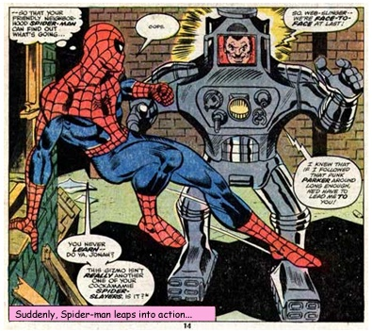
To Kill a Mockingbird

Comic Strip Trial Rubric

CATEGORY | 4 | 3 | 2 | 1
Mandatory Elements | All elements outlined on the assignment sheet are present. | One element outlined on the assignment sheet is missing. | Two elements outlined on the assignment sheet are missing. | Three or more elements outlined on the assignment sheet are missing.
Chapter Details | The significant plot details for the chapter are very clearly presented in both words and pictures. | The significant plot details for the chapter are somewhat clearly presented in both words and pictures. | The significant plot details for the chapter are less than clearly presented in both words and pictures. | The comic strip is not complete.
Presentation | A great deal of care was obviously employed in the completion of the comic strip. A ruler was used, etc. | Some evidence of an effort to produce a neat assignment is evident. | No evidence of an effort to produce a neat assignment is evident. | The comic strip is not complete.

